DIGITAL SYSTEM DESIGN LABORATORY
REPORT LAB 2

IMPLEMENTATION OF SEQUENTIAL LOGIC CIRCUITS USING VERILOG AND VHDL IN FPGA KIT

NAME: Bùi Gia Bảo

ID: ITITIU22019

I. LAB OBJECTIVES

This Lab experiments are intended to implement Basic Sequential Circuits in Verilog. Students are require to write test bench to simulate the given example code and Top level module to implement these codes in DE2-115 FPGA Kit.

II. LAB EXPERIMENT EXERCISES

AIM: WRITE VHDL OR VHDL CODES TO SIMULATE AND IMPLEMENT THE FOLLOWING DIGITAL SEQUENTIAL LOGIC CIRCUITS:

- DFF with Asynchronous Reset using Verilog
- DFF with Synchronous Reset using VHDL
- JK Flip Flop VHDL
- Asynchronous Counter 4-bit using VHDL structural modeling
- Asynchronous Counter 8-bit using VHDL behavior modeling
- Synchronous Counter 4-bit using Verilog structural modeling
- Synchronous Counter n-bit VHDL behavior modeling
- Right Shift Register 4-bit using Verilog structural modeling
- Left Shift Register 4-bit VHDL structural modeling
- Universal Shift Register N-bit Verilog behavior modeling
- Universal Shift Register N-bit VHDL behavior modeling

1/ DFF with Asynchronous Reset using Verilog

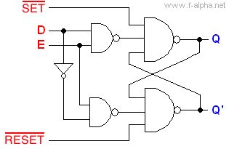

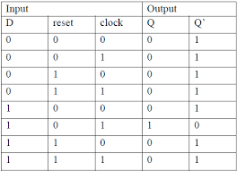

CODE

module lab2_ex1(SW,LEDG,LEDR);

input[2:0] SW;

output [1:0] LEDG;

output [2:0] LEDR;

assign LEDR=SW;

dff_async_reset test(SW[0],SW[1],SW[2],LEDG[0]);

endmodule

module dff_async_reset (

input wire data, // Data input

input wire reset, // Asynchronous reset input

input wire clk, // Clock input

output reg q // Output

);

always @ (posedge clk or negedge reset) begin

// If reset is active (assuming active-low reset)

if (~reset) begin

q <= 1'b0; // Reset the output

end else begin

q <= data; // Capture the data on the clock edge

end

end

endmodule

2/ DFF with Synchronous Reset using VHDL
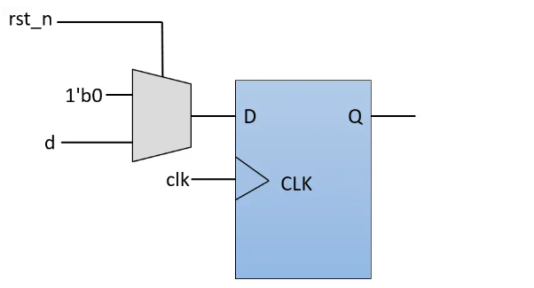
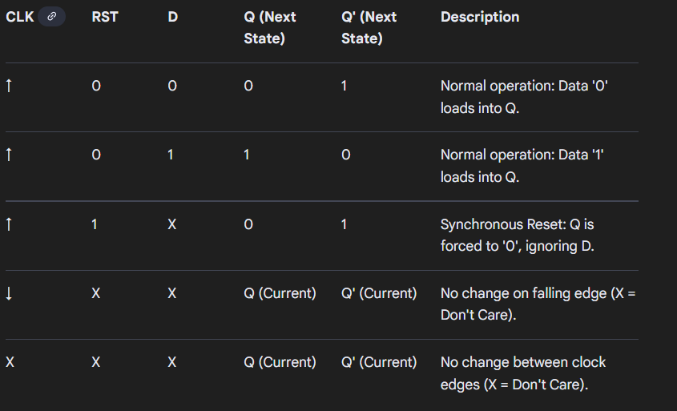

library IEEE;
use IEEE.STD_LOGIC_1164.ALL;

entity ex2_vhdl is
Port (
SW : in STD_LOGIC_VECTOR(2 downto 0); -- SW(0)=clk, SW(1)=reset, SW(2)=D
LEDG : out STD_LOGIC_VECTOR(1 downto 0);
LEDR : out STD_LOGIC_VECTOR(2 downto 0)
);
end ex2_vhdl;

architecture Structural of ex2_vhdl is

-- Internal component declaration for DFF
component dff_sync
Port (
clk : in STD_LOGIC;
reset : in STD_LOGIC;
d : in STD_LOGIC;
q : out STD_LOGIC
);
end component;

begin
-- Connect switches to red LEDs
LEDR <= SW;

-- Instantiate D Flip-Flop (Synchronous Reset)
test: dff_sync
port map (
clk => SW(0),
reset => SW(1),
d => SW(2),
q => LEDG(0)
);

-- Unused green LED output (set to 0)
LEDG(1) <= '0';

end Structural;

library IEEE;
use IEEE.STD_LOGIC_1164.ALL;

entity dff_sync is
Port (
clk : in STD_LOGIC;
reset : in STD_LOGIC;
d : in STD_LOGIC;
q : out STD_LOGIC
);
end dff_sync;

architecture Behavioral of dff_sync is
signal q_reg : STD_LOGIC := '0';
begin
process (clk)
begin
if rising_edge(clk) then
if reset = '1' then
q_reg <= '0';
else
q_reg <= d;
end if;
end if;
end process;
q <= q_reg;
end Behavioral;

3/ JK Flip Flop VHDL
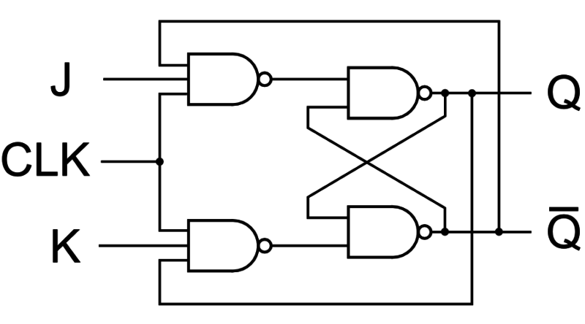
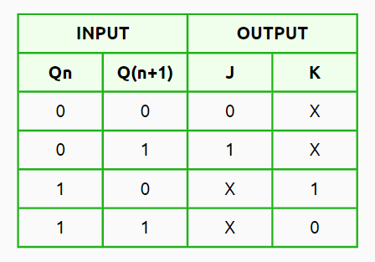

library IEEE;
use IEEE.STD_LOGIC_1164.ALL;

-- ==========================================================
-- Top-Level Entity: ex3_vhdl
-- Description: JK Flip-Flop with Asynchronous Reset
-- ==========================================================
entity ex3_vhdl is
Port (
SW : in STD_LOGIC_VECTOR(3 downto 0); -- SW(0)=CLK, SW(1)=J, SW(2)=K, SW(3)=RESET
LEDG : out STD_LOGIC_VECTOR(1 downto 0); -- LEDG(0)=Q, LEDG(1)=Q'
LEDR : out STD_LOGIC_VECTOR(3 downto 0) -- Mirrors SW
);
end ex3_vhdl;

architecture Structural of ex3_vhdl is
-- Component declaration for JK Flip-Flop
component jk_ff
Port (
clk : in STD_LOGIC;
j : in STD_LOGIC;
k : in STD_LOGIC;
reset : in STD_LOGIC; -- Active-high asynchronous reset
q : out STD_LOGIC
);
end component;

signal Q_sig : STD_LOGIC;

begin
-- Connect switches to red LEDs
LEDR <= SW;

-- Instantiate JK Flip-Flop
DUT: jk_ff
port map (
clk => SW(0),
j => SW(1),
k => SW(2),
reset => SW(3),
q => Q_sig
);

-- Output Q and its complement
LEDG(0) <= Q_sig;
LEDG(1) <= not Q_sig;

end Structural;

-- ==========================================================
-- Submodule: JK Flip-Flop (Asynchronous Reset)
-- ==========================================================
library IEEE;
use IEEE.STD_LOGIC_1164.ALL;

entity jk_ff is
Port (
clk : in STD_LOGIC;
j : in STD_LOGIC;
k : in STD_LOGIC;
reset : in STD_LOGIC;
q : out STD_LOGIC
);
end jk_ff;

architecture Behavioral of jk_ff is
signal q_reg : STD_LOGIC := '0';
signal jk_vec : STD_LOGIC_VECTOR(1 downto 0);
begin
jk_vec <= j & k; -- Explicitly make a 2-bit vector

process (clk, reset)
begin
if reset = '1' then
q_reg <= '0'; -- Asynchronous reset
elsif rising_edge(clk) then
case jk_vec is
when "00" => q_reg <= q_reg; -- No change
when "01" => q_reg <= '0'; -- Reset
when "10" => q_reg <= '1'; -- Set
when "11" => q_reg <= not q_reg; -- Toggle
when others => null;
end case;
end if;
end process;

q <= q_reg;
end Behavioral;

4/ Asynchronous Counter 4-bit using VHDL structural modeling
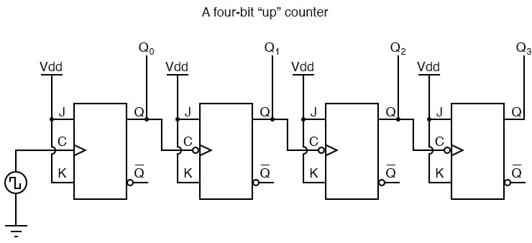
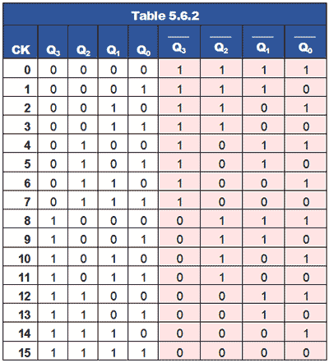

library IEEE;
use IEEE.STD_LOGIC_1164.ALL;
use IEEE.NUMERIC_STD.ALL;

entity ex4_vhdl is
port (
CLOCK_50 : in STD_LOGIC; -- 50 MHz clock input
SW : in STD_LOGIC_VECTOR(0 downto 0); -- SW(0) = active-low reset
LEDG : out STD_LOGIC_VECTOR(3 downto 0); -- 4-bit counter output
LEDR : out STD_LOGIC_VECTOR(0 downto 0) -- mirror reset switch
);
end ex4_vhdl;

architecture rtl of ex4_vhdl is

signal clk_1Hz : STD_LOGIC := '0';
signal q : STD_LOGIC_VECTOR(3 downto 0) := (others => '0');

begin

-- Mirror reset switch on LEDR
LEDR <= SW;

-- Instantiate 1 Hz Clock Divider
Divider: entity work.clock_divider_1Hz
port map (
clk_in => CLOCK_50,
reset_n => SW(0),
clk_out => clk_1Hz
);

-- Asynchronous Ripple Counter
process(clk_1Hz, SW)
begin
if SW(0) = '0' then
q(0) <= '0';
elsif rising_edge(clk_1Hz) then
q(0) <= not q(0);
end if;
end process;

process(q(0), SW)
begin
if SW(0) = '0' then
q(1) <= '0';
elsif falling_edge(q(0)) then
q(1) <= not q(1);
end if;
end process;

process(q(1), SW)
begin
if SW(0) = '0' then
q(2) <= '0';
elsif falling_edge(q(1)) then
q(2) <= not q(2);
end if;
end process;

process(q(2), SW)
begin
if SW(0) = '0' then
q(3) <= '0';
elsif falling_edge(q(2)) then
q(3) <= not q(3);
end if;
end process;

LEDG <= q;

end rtl;

--==============================================================
-- 50 MHz to 1 Hz Clock Divider
--==============================================================
library IEEE;
use IEEE.STD_LOGIC_1164.ALL;
use IEEE.NUMERIC_STD.ALL;

entity clock_divider_1Hz is
port (
clk_in : in STD_LOGIC;
reset_n : in STD_LOGIC; -- Active-low reset
clk_out : out STD_LOGIC
);
end clock_divider_1Hz;

architecture rtl of clock_divider_1Hz is
signal count : unsigned(25 downto 0) := (others => '0');
signal clk_reg : STD_LOGIC := '0';
begin

process(clk_in, reset_n)
begin
if reset_n = '0' then
count <= (others => '0');
clk_reg <= '0';
elsif rising_edge(clk_in) then
if count = 24999999 then -- Toggle every 0.5s for 1Hz period
count <= (others => '0');
clk_reg <= not clk_reg;
else
count <= count + 1;
end if;
end if;
end process;

clk_out <= clk_reg;

end rtl;

5/ Asynchronous Counter 8-bit using VHDL behavior modeling
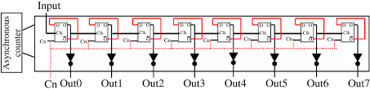

CODE

library IEEE;
use IEEE.STD_LOGIC_1164.ALL;
use IEEE.NUMERIC_STD.ALL;

entity ex5_vhdl is
port (
CLOCK_50 : in STD_LOGIC; -- 50 MHz clock input
SW : in STD_LOGIC_VECTOR(0 downto 0); -- SW(0) = active-low reset
LEDG : out STD_LOGIC_VECTOR(7 downto 0); -- 4-bit counter output
LEDR : out STD_LOGIC_VECTOR(0 downto 0) -- mirror reset switch
);
end ex5_vhdl;

architecture rtl of ex5_vhdl is

signal clk_1Hz : STD_LOGIC := '0';
signal q : STD_LOGIC_VECTOR(7 downto 0) := (others => '0');

begin

-- Mirror reset switch on LEDR
LEDR <= SW;

-- Instantiate 1 Hz Clock Divider
Divider: entity work.clock_divider_1Hz
port map (
clk_in => CLOCK_50,
reset_n => SW(0),
clk_out => clk_1Hz
);

-- Asynchronous Ripple Counter
process(clk_1Hz, SW)
begin
if SW(0) = '1' then
q(0) <= '0';
elsif rising_edge(clk_1Hz) then
q(0) <= not q(0);
end if;
end process;

process(q(0), SW)
begin
if SW(0) = '1' then
q(1) <= '0';
elsif falling_edge(q(0)) then
q(1) <= not q(1);
end if;
end process;

process(q(1), SW)
begin
if SW(0) = '1' then
q(2) <= '0';
elsif falling_edge(q(1)) then
q(2) <= not q(2);
end if;
end process;

process(q(2), SW)
begin
if SW(0) = '1' then
q(3) <= '0';
elsif falling_edge(q(2)) then
q(3) <= not q(3);
end if;
end process;

process(q(3), SW)
begin
if SW(0) = '1' then
q(4) <= '0';
elsif falling_edge(q(3)) then
q(4) <= not q(4);
end if;
end process;

process(q(4), SW)
begin
if SW(0) = '1' then
q(5) <= '0';
elsif falling_edge(q(4)) then
q(5) <= not q(5);
end if;
end process;

process(q(5), SW)
begin
if SW(0) = '1' then
q(6) <= '0';
elsif falling_edge(q(5)) then
q(6) <= not q(6);
end if;
end process;

process(q(6), SW)
begin
if SW(0) = '1' then
q(7) <= '0';
elsif falling_edge(q(6)) then
q(7) <= not q(7);
end if;
end process;

LEDG <= q;

end rtl;

library IEEE;
use IEEE.STD_LOGIC_1164.ALL;
use IEEE.NUMERIC_STD.ALL;

entity clock_divider_1Hz is
port (
clk_in : in STD_LOGIC;
reset_n : in STD_LOGIC; -- Active-low reset
clk_out : out STD_LOGIC
);
end clock_divider_1Hz;

architecture rtl of clock_divider_1Hz is
signal count : unsigned(25 downto 0) := (others => '0');
signal clk_reg : STD_LOGIC := '0';
begin

process(clk_in, reset_n)
begin
if reset_n = '1' then
count <= (others => '0');
clk_reg <= '0';
elsif rising_edge(clk_in) then
if count = 24999999 then -- Toggle every 0.5s for 1Hz period
count <= (others => '0');
clk_reg <= not clk_reg;
else
count <= count + 1;
end if;
end if;
end process;

clk_out <= clk_reg;

end rtl;

6/ Synchronous Counter 4-bit using Verilog structural modeling
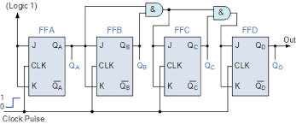

7/ Synchronous Counter n-bit VHDL behavior modeling

8/ Right Shift Register 4-bit using Verilog structural modeling
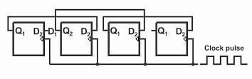

module ex8_verilog(SW, LEDG, LEDR);
input [3:0] SW; // SW[0]=CLK, SW[1]=d, SW[2]=input, SW[3]=ASYNC_RESET
output [3:0] LEDG; // LEDG[0]=Q, LEDG[1]=Q'
output [3:0] LEDR; // Mirrors switch input

assign LEDR = SW;
wire q0, q1, q2, q3;
wire d0, d1, d2, d3;

assign d3 = SW[2];
assign d2 = q3;
assign d1 = q2;
assign d0 = q1;

// Instantiate JK Flip-Flop
jkff_structural JK3 (
.clk(SW[0]),
.d(d3),
.reset(SW[3]),
.q(q3),
.qbar(Qbar)
);
jkff_structural JK2 (
.clk(SW[0]),
.d(d2),
.reset(SW[3]),
.q(q2),
.qbar(Qbar)
);
jkff_structural JK1 (
.clk(SW[0]),
.d(d1),
.reset(SW[3]),
.q(q1),
.qbar(Qbar)
);
jkff_structural JK0 (
.clk(SW[0]),
.d(d0),
.reset(SW[3]),
.q(q0),
.qbar(Qbar)
);

assign LEDG = {q3,q2,q1,q0};

endmodule

module jkff_structural(
input clk, d, reset,
output q, qbar
);
wire jn, kn, dnot;
wire s1, r1, s2, r2;
wire qm, qmb; // master latch output

// Invert reset
wire nreset;
not (nreset, reset);
not(dnot,d);

// Input gating for master latch
nand (s1, d, qmb, clk);
nand (r1, dnot, qm, clk);

// Master latch
nand (qm, s1, qmb, nreset);
nand (qmb, r1, qm, nreset);

// Slave latch (triggered on inverted clock)
nand (s2, qm, ~clk);
nand (r2, qmb, ~clk);
nand (q, s2, qbar, nreset);
nand (qbar, r2, q, nreset);
endmodule

9/ Left Shift Register 4-bit VHDL structural modeling

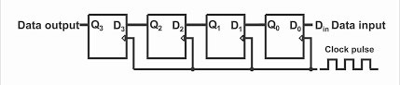

CODE
library IEEE;
use IEEE.STD_LOGIC_1164.ALL;

--==================================================
-- D-type JK-style flip-flop (structural form, no qbar)
--==================================================
entity jkff_structural is
port (
clk : in std_logic;
d : in std_logic;
reset : in std_logic;
q : out std_logic
);
end jkff_structural;

architecture structural of jkff_structural is
signal nreset, dnot : std_logic;
signal s1, r1, s2, r2 : std_logic;
signal qm, qmb : std_logic;
begin
nreset <= not reset;
dnot <= not d;

-- Input gating for master latch
s1 <= not (d and qmb and clk);
r1 <= not (dnot and qm and clk);

-- Master latch
qm <= not (s1 and qmb and nreset);
qmb <= not (r1 and qm and nreset);

-- Slave latch (triggered on inverted clock)
s2 <= not (qm and (not clk));
r2 <= not (qmb and (not clk));
q <= not (s2 and r2 and nreset);
end structural;

--==================================================
-- Top-level module (equivalent to ex9_verilog)
--==================================================
library IEEE;
use IEEE.STD_LOGIC_1164.ALL;

entity ex9_vhdl is
port (
SW : in std_logic_vector(3 downto 0); -- SW[0]=CLK, SW[1]=d, SW[2]=input, SW[3]=ASYNC_RESET
LEDG : out std_logic_vector(3 downto 0); -- Q outputs
LEDR : out std_logic_vector(3 downto 0) -- Mirrors switch input
);
end ex9_vhdl;

architecture behavioral of ex9_vhdl is
signal q0, q1, q2, q3 : std_logic;
signal d0, d1, d2, d3 : std_logic;
begin
LEDR <= SW;

d3 <= SW(2);
d2 <= q3;
d1 <= q2;
d0 <= q1;

-- Instantiate Flip-Flops
JK3: entity work.jkff_structural
port map(clk => SW(0), d => d3, reset => SW(3), q => q3);

JK2: entity work.jkff_structural
port map(clk => SW(0), d => d2, reset => SW(3), q => q2);

JK1: entity work.jkff_structural
port map(clk => SW(0), d => d1, reset => SW(3), q => q1);

JK0: entity work.jkff_structural
port map(clk => SW(0), d => d0, reset => SW(3), q => q0);

-- Output assignment
LEDG <= (q3 & q2 & q1 & q0);
end behavioral;
10/ Universal Shift Register N-bit Verilog behavior modeling

11/ Universal Shift Register N-bit VHDL behavior modeling

